Name: Vishnu Mohan
Roll No: 51
Batch: MCA B
Date: 02-06-2022

NETWORKING & SYSTEM ADMINISTRATION LAB

Experiment No.: 25

Aim
To familiarize with the installation of Cmake
Procedure
1. Open the terminal on Ubuntu
2. To install cmake , g++ and make using the apt command.
Sudo apt install cmake g++ make
Output:-
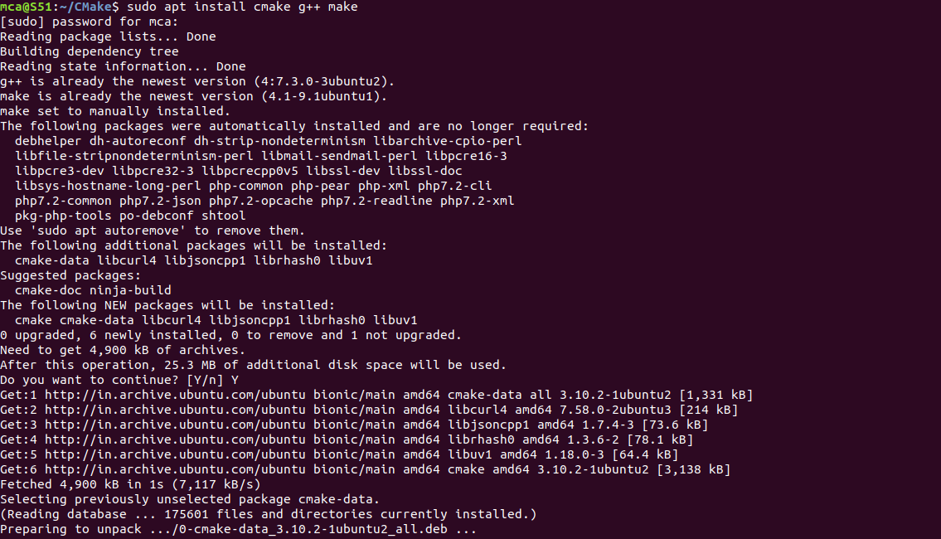

3. Creating a different directory for our project using the mkdir and cd commands.
mkdir myproject
Output:-
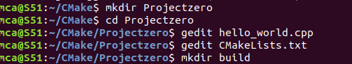

4. Now create a C++ source file named Hello_world.cpp and add the following
Output:-
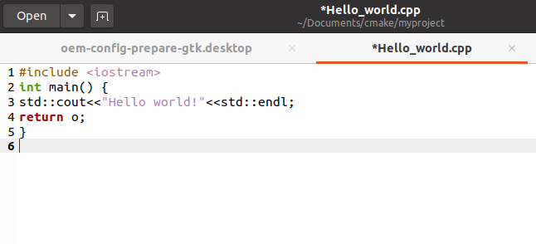

5. Create a CMakeLists.txt file(with this exact capitalization) which is required by Cmake:
The CMakeLists.txt file for this project will only contain these three lines:
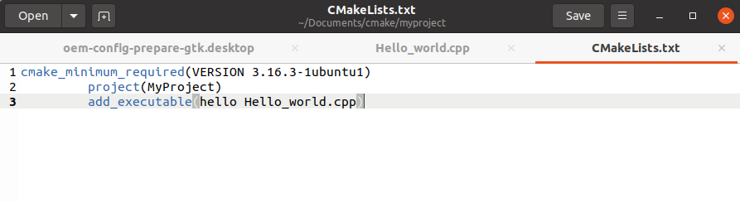

6. Build directory for executables :
run cmake we need to change into the build directory:
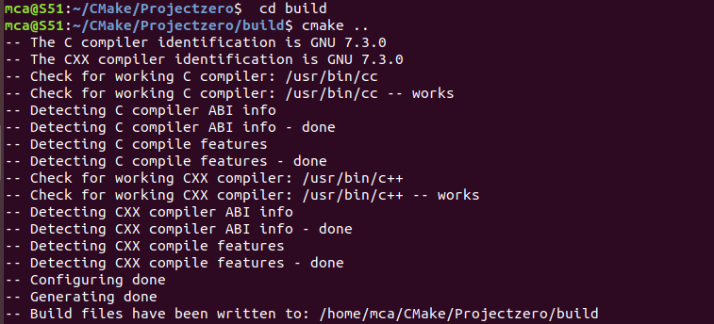
7. To generate the executable simply by typing:
cmake --build .

Output:-
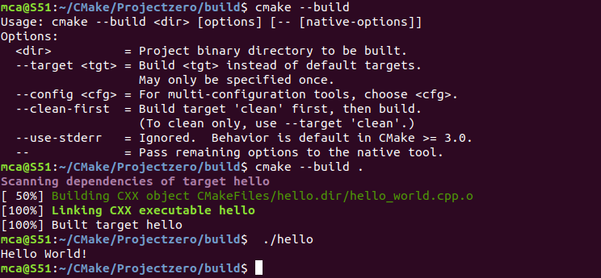
8. Run the executable by typing:

./hello

Output:-

